**PIZZA SALES SQL QUERIES**

**A. KPI’s**

**1. Total Revenue:**

SELECT ROUND(SUM(total_price),2) AS Total_Revenue FROM pizza_sales;

***Output:***

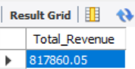

**2. Average Order Value**

SELECT ROUND(SUM(total_price)/COUNT(distinct(order_id)),2) AS Avg_Amt_per_Order FROM pizza_sales;

***Output:***

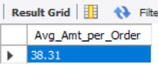

**3. Total Pizzas Sold**

SELECT SUM(quantity) AS Total_Pizza_Sold FROM pizza_sales;

***Output:***

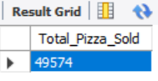

**4. Total Orders**

SELECT COUNT(DISTINCT(order_id)) AS Total_Order_Placed FROM pizza_sales;

***Output:***



**5. Average Pizzas Per Order**

SELECT ROUND(SUM(quantity)/COUNT(DISTINCT(order_id)),2) AS Avg_Pizza_per_Order FROM pizza_sales;

***Output:***

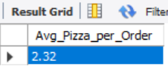

**B. Daily Trend for Total Orders**SELECT DAYNAME(STR_TO_DATE(order_date,'%d-%m-%YYYY')) AS Days, COUNT(DISTINCT(order_id)) AS Total_Orders FROM pizza_sales GROUP BY Days;

***Output:***

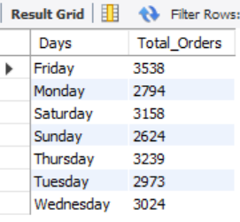

**C. Hourly Trend for Total Orders**

SELECT HOUR(order_time) AS order_time, COUNT(DISTINCT(order_id)) AS Total_Orders FROM pizza_sales GROUP BY HOUR(order_time);

***Output:***

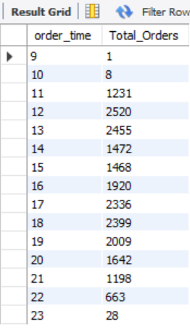

**D. Monthly Trend for Orders**

SELECT MONTHNAME(STR_TO_DATE(order_date,'%d-%m-%YYYY')) AS Months, COUNT(DISTINCT(order_id)) AS Total_Orders FROM pizza_sales GROUP BY Months;

***Output:***

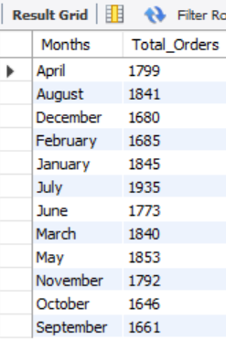

**E. % of Sales by Pizza Category**

SELECT DISTINCT(pizza_category), ROUND(SUM(total_price),2) AS Total_Sales, ROUND(SUM(total_price)*100/(SELECT SUM(total_price) FROM pizza_sales),2) AS Sales_in_Percent FROM pizza_sales GROUP BY pizza_category;

***Output:***

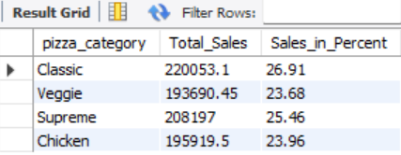

**F. % of Sales by Pizza Size**

SELECT DISTINCT(pizza_size), ROUND(SUM(total_price),2) AS Total_Sales, ROUND(SUM(total_price)*100/(SELECT SUM(total_price) FROM pizza_sales),2) AS Sales_in_Percent FROM pizza_sales GROUP BY pizza_size;

***Output:***

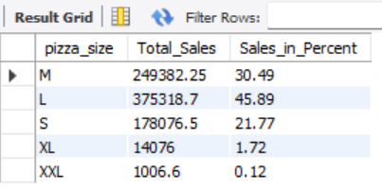

**G. Total Pizzas Sold by Pizza Category**

SELECT DISTINCT(pizza_category), ROUND(SUM(total_price),2) AS Total_Sales, ROUND(SUM(total_price)*100/(SELECT SUM(total_price) FROM pizza_sales),2) AS Sales_in_Percent FROM pizza_sales GROUP BY pizza_category;

***Output:***

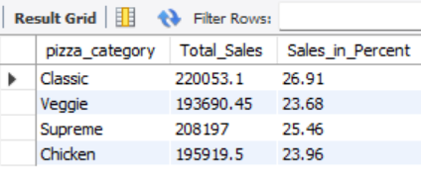

**H. Top 5 Pizzas by Revenue**

SELECT pizza_name, SUM(total_price) AS Total_Price FROM pizza_sales

GROUP BY pizza_name ORDER BY Total_Price DESC LIMIT 5;

***Output:***

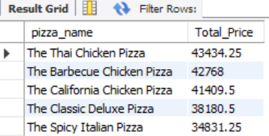

**I. Bottom 5 Pizzas by Revenue**

SELECT pizza_name, SUM(total_price) AS Total_Price FROM pizza_sales

GROUP BY pizza_name ORDER BY Total_Price ASC LIMIT 5;

***Output:***

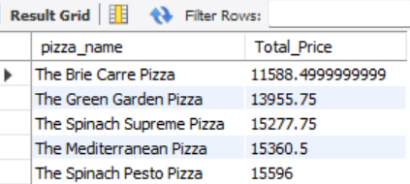

**J. Top 5 Pizzas by Quantity**

SELECT pizza_name, SUM(quantity) AS Total_Quantity FROM pizza_sales GROUP BY pizza_name ORDER BY Total_Quantity DESC LIMIT 5;

***Output:***

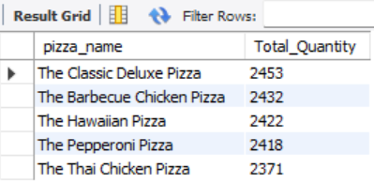

**K. Bottom 5 Pizzas by Quantity**

SELECT pizza_name, SUM(quantity) AS Total_Quantity FROM pizza_sales

GROUP BY pizza_name ORDER BY Total_Quantity ASC LIMIT 5;

***Output:***

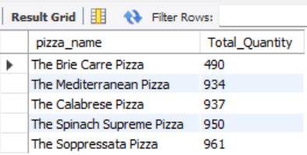

**L. Top 5 Pizzas by Total Orders**

SELECT pizza_name, COUNT(DISTINCT(order_id)) AS Total_Orders FROM pizza_sales

GROUP BY pizza_name ORDER BY Total_Orders DESC LIMIT 5;

***Output:***

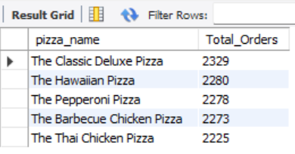

**M. Bottom 5 Pizzas by Total Orders**

SELECT pizza_name, COUNT(DISTINCT(order_id)) AS Total_Orders FROM pizza_sales

GROUP BY pizza_name ORDER BY Total_Orders ASC LIMIT 5;

***Output:***

